Experiment 3
Aim: To implement fundamental text cleaning and preprocessing techniques.
Code:
a. Removing HTML tags, extra whitespaces, and special characters.
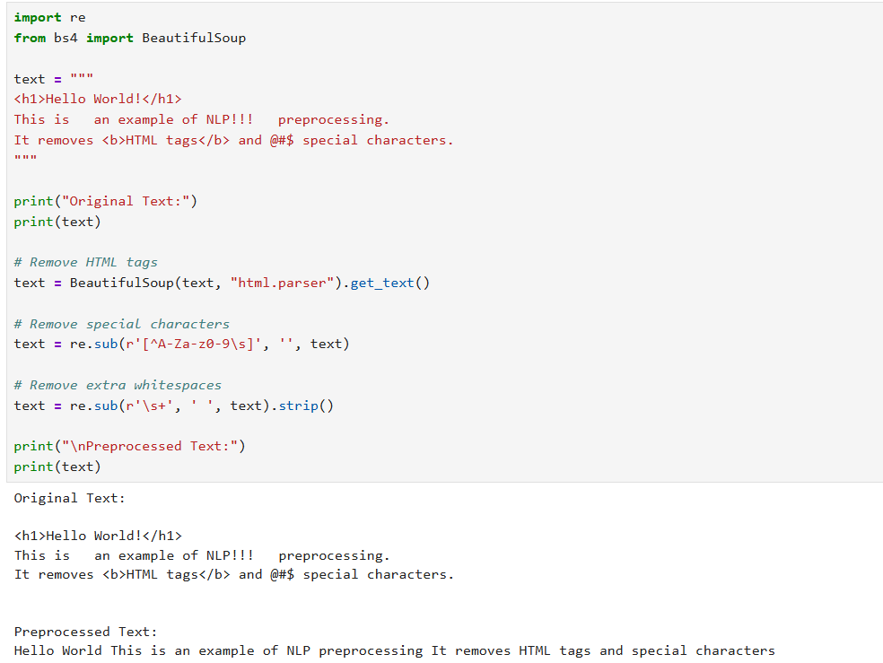
b. Sentence boundary detection, expanding contractions.
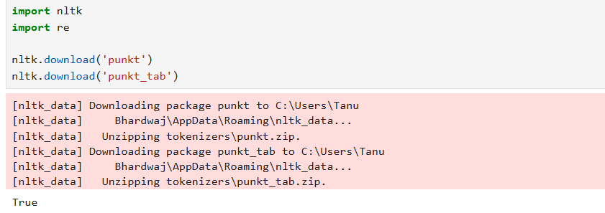
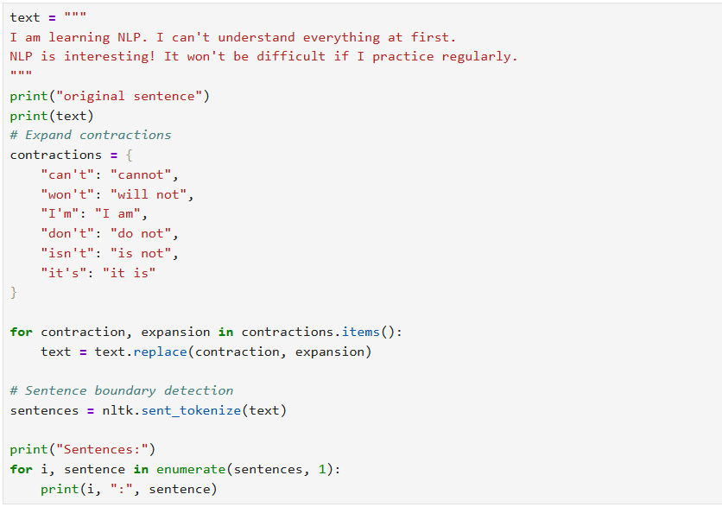
Output:
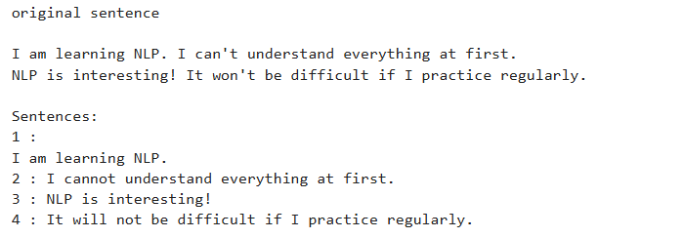
c. Lowercasing text, converting number words to numeric form, removing numbers and stopwords.
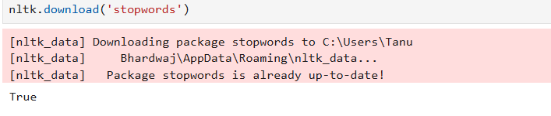
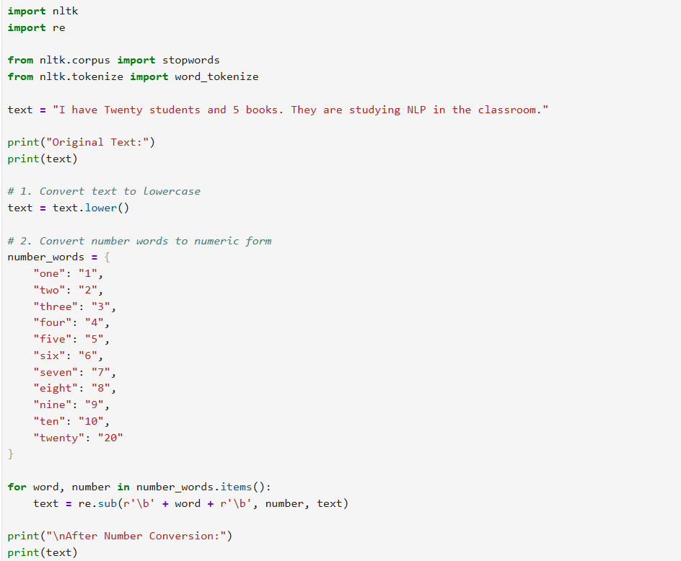
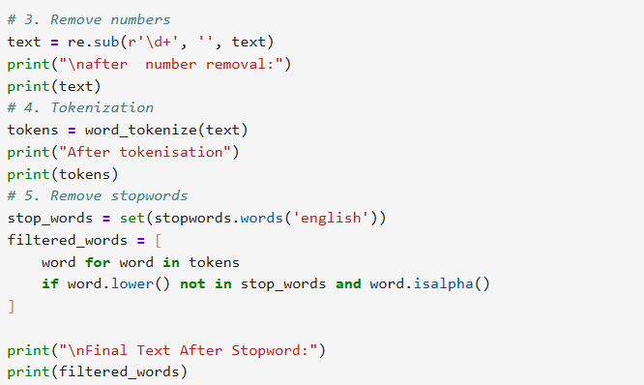
Output:
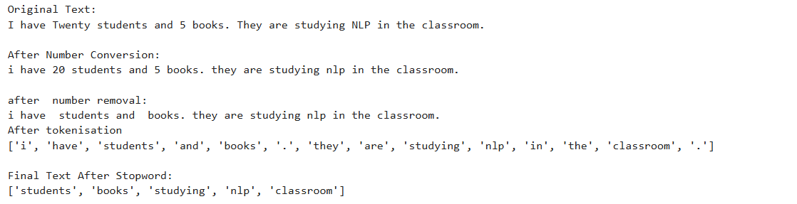

d. Phrase extraction, tokenization, and script validation.
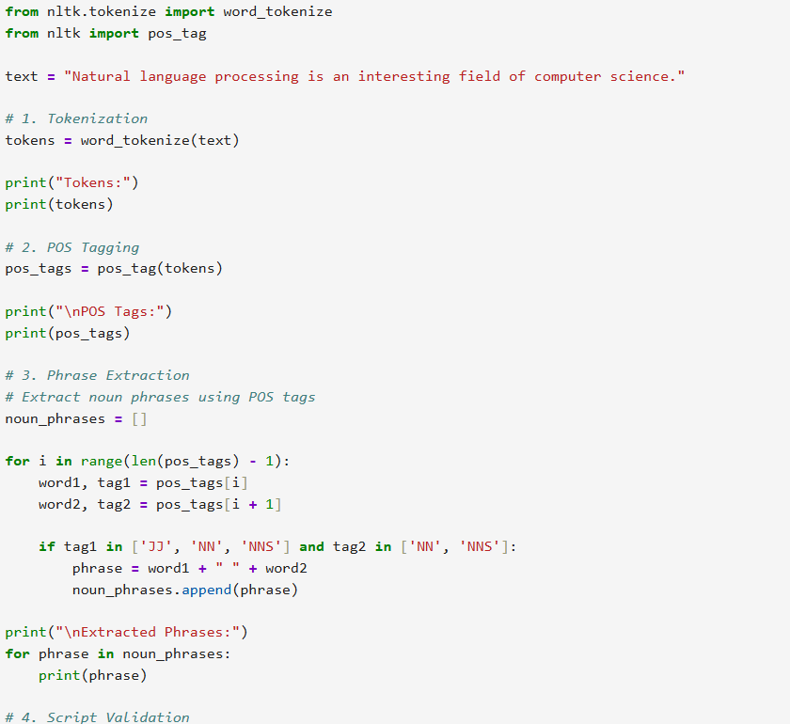
Output:
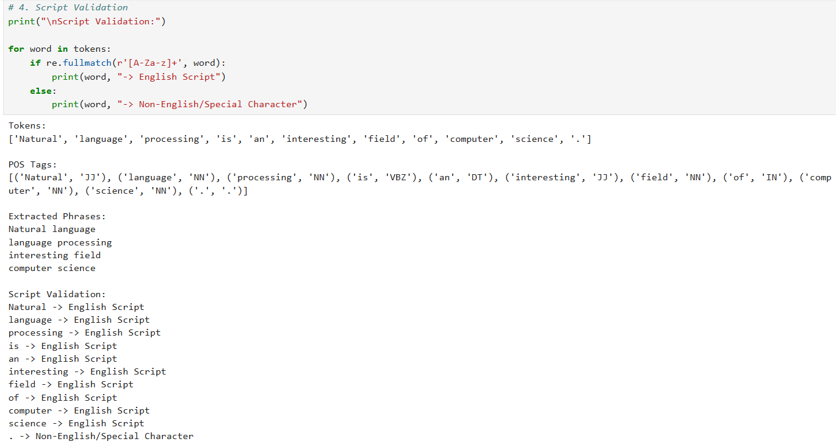
e. Handling different types of textual data and visualizing preprocessing impacts.
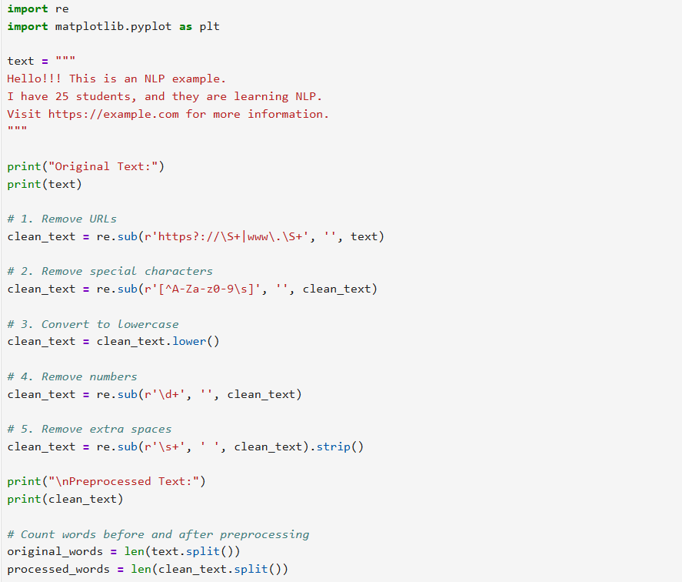
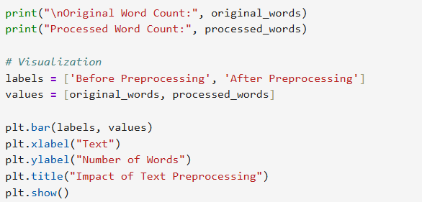
Output:
